Lab task 1
Name= Abdul ahad
Roll no =2502047
Q1.1-
Code:
#include<iostream>
using namespace std;
int main (){
int arr[10];
cout<<"enter 10 numbers"<<endl;
for (int i=0;i<10;i++){
cin>>arr[i];
}
cout<<"number with there index"<<endl;
for(int i=0;i<10;i++){
cout<<"index :"<<i<<":"<<arr[i]<<endl;
}
return 0;
}
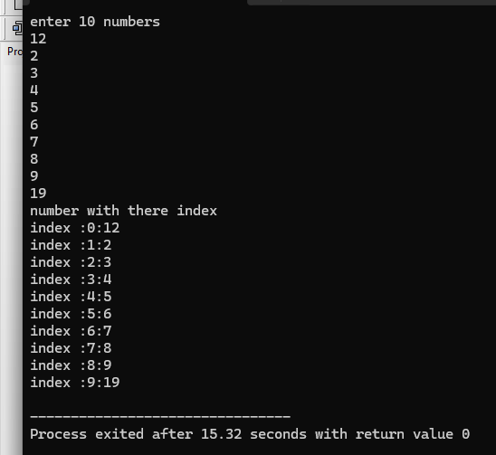

Q2.1
Code:
#include <iostream>
using namespace std;

int main() {
int arr[10];
int even = 0, odd = 0;
cout << "Enter 10 integers:" << endl;
for (int i = 0; i < 10; i++) {
cin >> arr[i];
}

for (int i = 0; i < 10; i++) {
if (arr[i] % 2 == 0)
even++;
else
odd++;
}
cout << "\nNumber of even elements = " << even << endl;
cout << "Number of odd elements = " << odd << endl;

return 0;
}

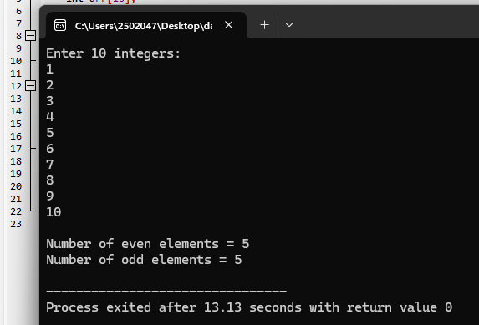
Q 3.1
Code:
#include <iostream>
using namespace std;

int main() {
int size;

cout << "Enter the size of the array: ";
cin >> size;
int* arr = new int[size];
cout << "Enter " << size << " elements:" << endl;
for (int i = 0; i < size; i++) {
cin >> arr[i];
}
cout << "Array elements are:" << endl;
for (int i = 0; i < size; i++) {
cout << arr[i] << " ";
}
delete[] arr;
return 0;
}
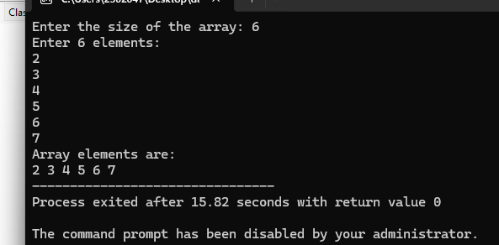
Q4.1
Code:
#include <iostream>
using namespace std;

int main() {
int arr[10];
cout << "Enter 10 integers:" << endl;

for (int i = 0; i < 10; i++) {
cin >> arr[i];
}
cout << "\nElements in forward order:" << endl;

for (int i = 0; i < 10; i++) {
cout << arr[i] << " ";
}
cout << "\n\nElements in reverse order:" << endl;

for (int i = 9; i >= 0; i--) {
cout << arr[i] << " ";
}

return 0;
}
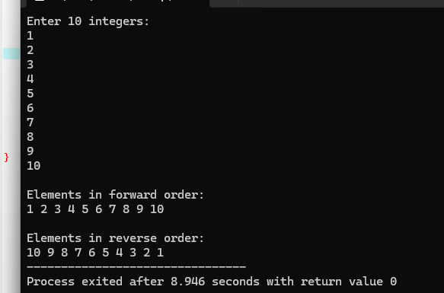
Q5.1
Code:
#include <iostream>
using namespace std;

int main() {
int arr[100];
int n, element, position;
cout << "Enter the number of elements: ";
cin >> n;
cout << "Enter " << n << " elements:" << endl;

for (int i = 0; i < n; i++) {
cin >> arr[i];
}
cout << "\nArray before insertion:" << endl;

for (int i = 0; i < n; i++) {
cout << arr[i] << " ";
}

cout << "\n\nEnter the new element: ";
cin >> element;

cout << "Enter the position (0 to " << n << "): ";
cin >> position;

for (int i = n; i > position; i--) {
arr[i] = arr[i - 1];
}
arr[position] = element;
n++;
cout << "\nArray after insertion:" << endl;

for (int i = 0; i < n; i++) {
cout << arr[i] << " ";
}

return 0;
}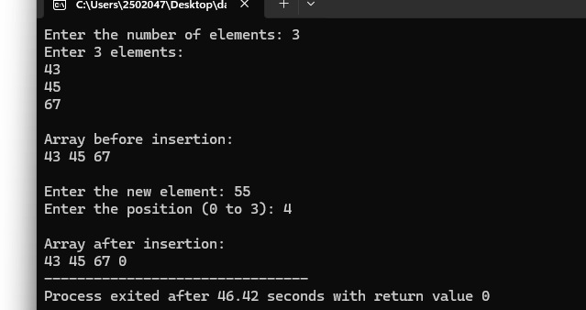
Q6.1
Code:
#include <iostream>
using namespace std;

int main() {
int arr[100];
int n, position;

cout << "Enter the number of elements: ";
cin >> n;
cout << "Enter " << n << " elements:" << endl;
for (int i = 0; i < n; i++) {
cin >> arr[i];
}
cout << "\nArray before deletion: ";
for (int i = 0; i < n; i++) {
cout << arr[i] << " ";
}
cout << "\n\nEnter the position to delete (0 to " << n - 1 << "): ";
cin >> position;

if (position < 0 || position >= n) {
cout << "Invalid position!" << endl;
}
for (int i = position; i < n - 1; i++) {
arr[i] = arr[i + 1];
}
n--;
cout << "\nArray after deletion: ";
for (int i = 0; i < n; i++) {
cout << arr[i] << " ";
}

return 0;
}
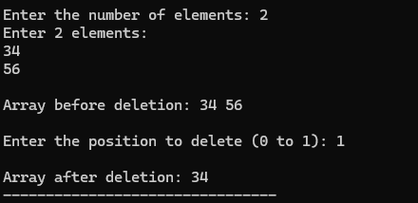
Q7.1
Code:
#include <iostream>
using namespace std;

int main() {
int arr[10];
int value;
int index = -1;
cout << "Enter 10 integers:" << endl;

for (int i = 0; i < 10; i++) {
cin >> arr[i];
}

cout << "Enter the value to search: ";
cin >> value;

for (int i = 0; i < 10; i++) {
if (arr[i] == value) {
index = i;
break;
}
}
if (index != -1) {
cout << "Element found at index " << index << endl;
}
else {
cout << "Element Not Found." << endl;
}

return 0;
}
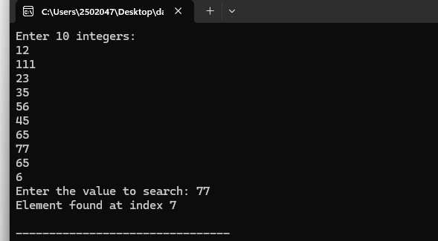
Q8.1
Code:
#include <iostream>
using namespace std;

int main() {
int arr[10];
int index, newValue;
cout << "Enter 10 integers:" << endl;

for (int i = 0; i < 10; i++) {
cin >> arr[i];
}

cout << "\nOriginal array: ";
for (int i = 0; i < 10; i++) {
cout << arr[i] << " ";
}
cout << "\n\nEnter the index you want to update (0-9): ";
cin >> index;
if (index < 0 || index >= 10) {
cout << "Invalid index!" << endl;
return 0;
}
cout << "Enter the new value: ";
cin >> newValue;
arr[index] = newValue;

cout << "\nUpdated array: ";

for (int i = 0; i < 10; i++) {
cout << arr[i] << " ";
}

return 0;
}
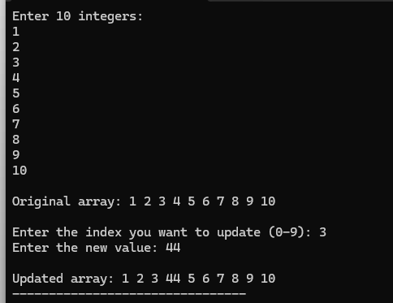
Q9.1
Code:
#include <iostream>
using namespace std;

int main() {
int matrix[3][3];
int sum = 0;
cout << "Enter elements of matrix:" << endl;
for (int i = 0; i < 3; i++) {
for (int j = 0; j < 3; j++) {
cin >> matrix[i][j];
}
}
for (int i = 0; i < 3; i++) {
for (int j = 0; j < 3; j++) {
sum = sum + matrix[i][j];
}
}
cout << "Sum of all elements = " << sum << endl;
return 0;
}
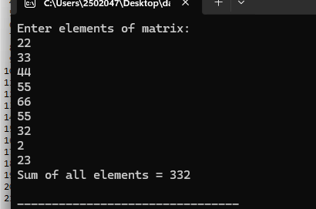
Q10.1
Code:
#include <iostream>
using namespace std;

int main() {
int arr[2][2][2];
cout << "Enter 8 elements:" << endl;
for (int layer = 0; layer < 2; layer++) {
for (int row = 0; row < 2; row++) {
for (int column = 0; column < 2; column++) {
cin >> arr[layer][row][column];
}
}
}
cout << "3D Array:" << endl;
for (int layer = 0; layer < 2; layer++) {
cout << "\nLayer " << layer + 1 << ":" << endl;

for (int row = 0; row < 2; row++) {
for (int column = 0; column < 2; column++) {
cout << arr[layer][row][column] << " ";
}
cout << endl;
}
}
return 0;
}
